AWS GLUE
Agenda
- Introduction to AWS Glue
- Key Features
- AWS Glue Architecture
- Components of AWS Glue
- Major Glue Components
- AWS Glue ETL
- AWS Athena
- Building of ETL Pipeline with AWS Glue
Introduction to AWS Glue:
AWS Glue is a serverless, fully managed ETL (Extract, Transform, Load) service provided by AWS. It helps organizations prepare, transform, and move data across various AWS and third-party data sources.
It is specifically designed to simplify the process of data integration for data lakes, analytics, and machine learning applications.
AWS Glue is an ETL (Extract, Transform, Load) and Data Integration service that automates data preparation for analytics, AI/ML, and data engineering. It allows users to discover, catalog, clean, transform, and move data between different storage and processing environments.
Key Features:
- Serverless: AWS Glue eliminates the need for infrastructure management by automatically provisioning and scaling resources based on workload, reducing operational effort and cost.
- Automatic Schema Discovery: Uses crawlers to scan data sources, detect their structure, and infer schemas automatically, simplifying data integration.
- Data Catalog: Maintains metadata about data sources in a central repository, enabling easy data discovery, governance, and management.
- Job Scheduling: Automates ETL workflows using triggers and workflows, allowing scheduled or event-driven data processing.
- Scalability: Dynamically scales resources up or down based on workload demand, ensuring efficient processing of large datasets.
- Supports Multiple Formats: Compatible with various data formats, including JSON, Parquet, Avro, ORC, and CSV, enabling seamless data transformation.
AWS Glue Architecture:
Data Catalog:
- The AWS Glue Data Catalog serves as a central repository to store metadata, making it easier to discover and manage your data. It stores details about the data sources, schemas, tables, and partitions.
- It allows users to catalog their data regardless of whether it’s stored in Amazon S3, RDS, Redshift, or any other data store.
Crawlers:
- Crawlers automatically scan data stores (e.g., Amazon S3) to infer the schema and create tables in the Data Catalog.
- Crawlers can be scheduled to run on a set frequency or triggered by events to ensure your metadata is always up-to-date.
ETL Jobs:
- The ETL (Extract, Transform, Load) Jobs define the data transformation logic. AWS Glue allows users to write jobs in Python or Scala to perform data cleaning, filtering, and transformation tasks.
- These jobs can be executed in a serverless environment, and AWS Glue automatically provisions the resources required to run the job.
Job Bookmarks:
- Job bookmarks help in keeping track of processed data, ensuring that AWS Glue does not reprocess the same data during subsequent job runs. This is useful for incremental data processing.
Triggers:
- AWS Glue provides triggers to automate the execution of ETL jobs. Triggers can be time-based (scheduled) or event-based, allowing data to be processed in real-time or at specified intervals.
Workflow:
- A workflow enables the orchestration of multiple jobs and triggers. You can define a sequence of operations, ensuring that jobs run in a specific order or based on dependencies, such as after a particular job completes.
Glue Development Endpoints:
- Development endpoints allow you to create, test, and debug custom ETL scripts interactively before running them as part of an AWS Glue job.
Scalability & Resource Management:
- AWS Glue automatically scales its resources based on workload demands. The computing power for ETL jobs is dynamically managed, optimizing cost and performance.
Security:
- AWS Glue integrates with AWS Identity and Access Management (IAM) for access control, ensuring that only authorized users can create, run, and access resources in Glue. Encryption of data is also supported for data in transit and at rest.
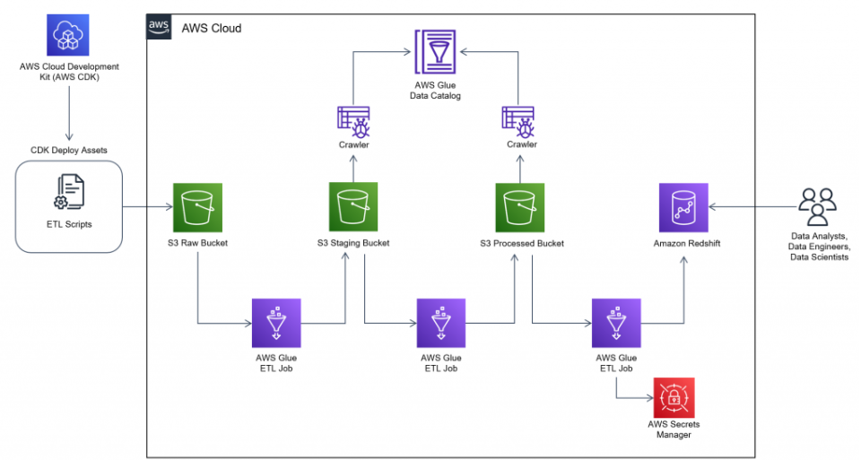
Components of AWS Glue:
- AWS Glue Data Catalog
- Centralized metadata repository.
- Stores schemas, tables, and partitions.
- AWS Glue Crawlers
- Automatically discovers datasets.
- Infers schema and structure.
- Registers metadata in the Glue Data Catalog.
- AWS Glue ETL Jobs
- Executes Apache PySpark-based ETL workflows.
- Supports PySpark and Scala for data transformations.
- AWS Glue Triggers & Workflows
- Automates job execution via time-based or event-driven triggers.
- Orchestrates end-to-end data pipelines.
- AWS Glue DataBrew
- No-code data preparation tool.
- Cleans and transforms raw data using a simple UI.
- AWS Glue Studio
- Visual interface for designing and managing ETL jobs.
- Simplifies the creation of complex data pipelines.
- AWS Glue Security & Compliance
- Integrates with IAM for fine-grained access control.
- Supports encryption for data security.
After opening AWS Glue, you will find on the left side, the two main categories of Components of AWS Glue, that are Data Catalog & Data Integration and ETL.
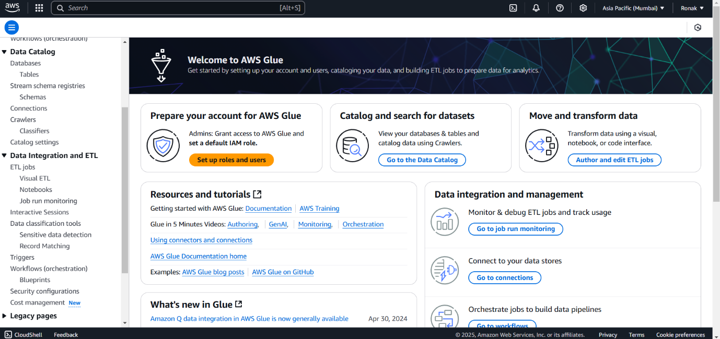
Most Used Glue Components:
1. AWS Glue Data Catalog:
- The AWS Glue Data Catalog is a central metadata repository for storing and managing information about data sources. It maintains metadata such as schema, tables, columns, and partitions, enabling seamless data discovery and access across various AWS services like Athena, Redshift Spectrum, and EMR. It serves as the cornerstone for managing the metadata of your datasets.
- Creating and Managing Databases and Tables:In AWS Glue Data Catalog, you can create and manage databases to organize datasets logically. A database is a container for tables, and each table holds metadata information about the dataset. You can create tables manually or by using crawlers to automatically register tables by discovering data from storage locations (e.g., S3).
2. AWS Glue Crawlers:
- AWS Glue Crawlers are automated tools that scan data stores to infer schema, create tables, and store metadata in the Glue Data Catalog. Crawlers help in discovering the structure of your data without the need for manual schema definition.
- Working of Crawlers:Crawlers work by scanning data stored in various locations such as Amazon S3, RDS, and other sources. They analyze the structure of data files and infer the schema, including column names, types, and partitions. The crawlers then register this information in the Glue Data Catalog.
- Creating a Crawler to Discover SchemaTo create a crawler, specify the data source location (e.g., S3 bucket), choose a connection to your data store (if necessary), and set the desired output database in the Glue Data Catalog. After running the crawler, it will create tables with the inferred schema in the designated database.
3. AWS Glue Jobs:
- AWS Glue Jobs are tasks that execute the ETL (Extract, Transform, Load) operations. Jobs can perform data transformation, cleaning, and loading between different data sources. AWS Glue jobs are powered by Apache Spark, enabling scalable and distributed data processing.
- Types of AWS Glue Jobs (Python Shell, Spark ETL)
  - Python Shell Jobs: Used to run simple Python scripts for data processing without needing Spark. These are ideal for lightweight data manipulation tasks.
  - Spark ETL Jobs: These jobs run Apache Spark-based ETL processes for large-scale data transformations, supporting both PySpark and Scala code.
- Running and Monitoring JobsOnce a Glue job is created, it can be executed either on-demand or scheduled. You can monitor jobs through AWS Glue Console or CloudWatch Logs to check for any issues, job status, and performance metrics.
4. AWS Glue Triggers:
- Triggers in AWS Glue are used to automate the execution of jobs based on specific conditions. They enable automated workflows by starting jobs on-demand, at scheduled times, or in response to events.
- Types of Triggers (On-Demand, Scheduled, Event-Based)
  - On-Demand Trigger: Manually invoked to start a job or workflow when needed.
  - Scheduled Trigger: Runs jobs at defined intervals, such as daily, weekly, or monthly.
  - Event-Based Trigger: Starts jobs in response to events, such as changes in an S3 bucket or the completion of another job.
- Automating ETL WorkflowsTriggers help automate data processing pipelines by defining when and how jobs should run. This enables seamless, hands-off data transformation without requiring manual intervention.
5. AWS Glue Workflows:
- AWS Glue Workflows allow you to orchestrate multiple jobs and triggers into a unified data pipeline. A workflow defines the sequence of job executions, data transformations, and dependencies. Workflows can be used to model complex data processing pipelines with multiple interdependent tasks.
- Creating and Managing WorkflowsWorkflows can be created using the AWS Glue Console or API. You define the order of job executions, set triggers to start the workflow, and manage job dependencies. AWS Glue tracks the status of each task in the workflow, helping ensure that each job runs in the correct order.
AWS Glue ETL (Extract, Transform, Load):
- ETL (Extract, Transform, Load) in AWS Glue refers to the process of extracting data from various sources, transforming it into a desired format, and then loading it into a target data store. AWS Glue automates much of this process, providing scalable and serverless data integration. With AWS Glue, users can create ETL jobs to handle data transformation tasks such as cleaning, filtering, aggregating, and enriching data for analytics and reporting.
- Writing ETL Scripts Using Python (PySpark)AWS Glue allows users to write ETL scripts using Python, specifically PySpark. PySpark is a Python API for Apache Spark, and it enables distributed data processing. The Glue ETL scripts are used to define the data extraction, transformation, and loading steps in a job. These scripts can be generated automatically or customized to meet specific requirements. PySpark scripts can leverage the power of Spark to perform complex transformations on large datasets efficiently.
Transforming Data Using AWS Glue DynamicFrames:
- DynamicFrames in AWS GlueDynamicFrames are an abstraction provided by AWS Glue to represent data in a flexible, schema-less format. They are designed for working with semi-structured data like JSON or XML, making them more versatile than Spark DataFrames. A key advantage of DynamicFrames is that they can handle data inconsistencies and schema variations, which are common in large datasets.
- Transforming Data with DynamicFramesDynamicFrames offer built-in methods to perform various data transformations, such as:
  - Mapping fields: Change column names, types, or apply transformations to fields.
  - Filtering rows: Remove unwanted data based on conditions.
  - Relational transformations: Convert DynamicFrames to Spark DataFrames for advanced transformations and then back to DynamicFrames when needed.
  - Handling nulls: Fill or drop null values during transformation.
DynamicFrames help ensure smoother data processing and transformation tasks in complex, large-scale ETL pipelines.
Using Glue Built-in Transforms:
AWS Glue provides several built-in transformations to simplify common ETL tasks:
- Relationalize: Converts nested JSON data into a relational table format.
- DropFields: Removes specified columns from the dataset.
- RenameField: Changes the name of a column.
- ApplyMapping: Maps one set of columns to another set with different names or types.
- Filter: Filters rows based on conditions.
- SelectFields: Selects a subset of columns.
- Join: Performs a join operation between two DynamicFrames.
These built-in transforms are optimized for common data processing needs and reduce the complexity of custom ETL scripts.
Connecting AWS Glue with S3, RDS, Redshift, and DynamoDB:
AWS Glue supports integration with several AWS services for data extraction and loading:
- S3 (Simple Storage Service):AWS Glue can read and write data from/to Amazon S3, which is commonly used for storing raw or processed data. You can use Glue to extract data from S3, transform it, and load it back into S3 in a different format.
- RDS (Relational Database Service):AWS Glue can connect to Amazon RDS instances to extract data from relational databases (e.g., MySQL, PostgreSQL) for transformation and loading into other systems or services.
- Redshift:AWS Glue can interact with Amazon Redshift to extract, transform, and load data between Redshift clusters and other data sources. Redshift is often used as a data warehouse, and Glue helps in moving data into Redshift for analytics.
- DynamoDB:AWS Glue can also integrate with Amazon DynamoDB, a fully managed NoSQL database, to perform ETL tasks on DynamoDB tables. You can extract data from DynamoDB, transform it, and store it in other databases or data lakes.
AWS Athena:
Amazon Athena is a serverless, interactive query service that enables you to analyze data stored in Amazon S3 using standard SQL. It allows you to run queries directly on your data without having to move it to another storage or database. Athena is a fast and cost-effective solution for analyzing large datasets stored in S3, as it charges based on the amount of data scanned by each query.
Key Features of Amazon Athena:
- Serverless: No infrastructure setup is required, and you only pay for the queries you run.
- SQL Queries on S3 Data: Athena allows you to run SQL queries on data stored in S3, making it easier to analyze structured, semi-structured, or unstructured data.
- Integration with AWS Glue: Athena integrates seamlessly with AWS Glue for schema discovery and cataloging, making it easier to query structured data without manually defining schemas.
- Cost-Effective: Athena charges based on the amount of data scanned by your queries, which helps optimize costs.
- Support for Multiple Formats: Athena supports various data formats like CSV, Parquet, ORC, JSON, and Avro, enabling analysis on a wide range of datasets.
- Scalable: Athena can handle large amounts of data and scale automatically, ensuring high performance for any query size.
Building of ETL Pipeline with AWS Glue :
Step 1: To begin, create a source bucket in Amazon S3 by clicking “Create bucket” and following the prompts; this bucket will store the CSV files. Next, create a target bucket that will serve as the destination for the transformed data. Additionally, set up an Athena bucket to store query results, ensuring efficient organization and retrieval of processed data.
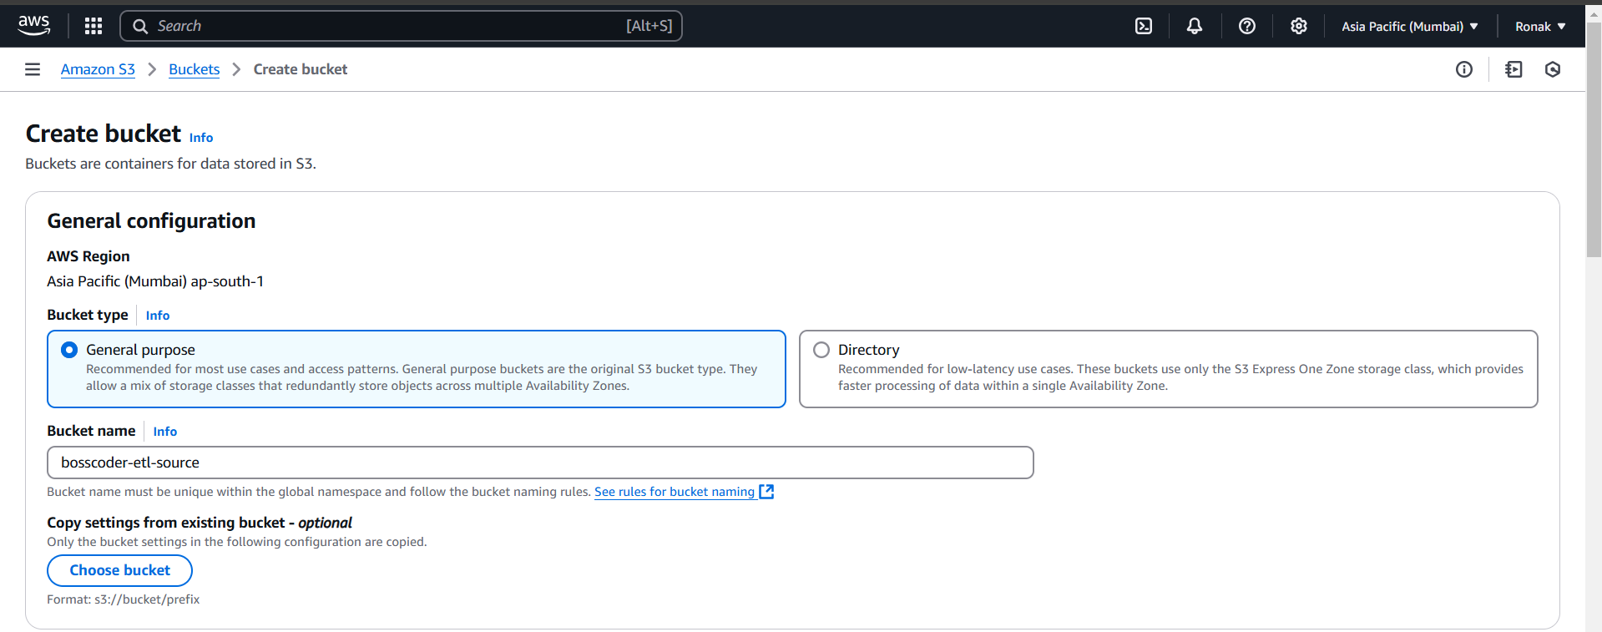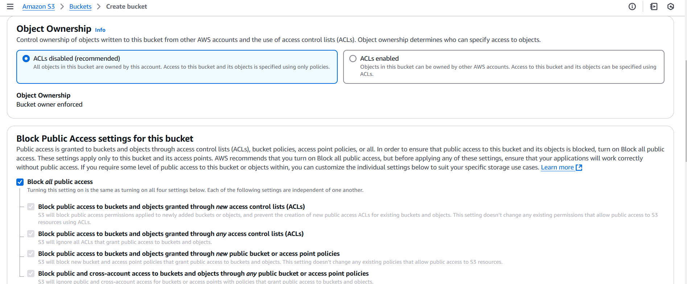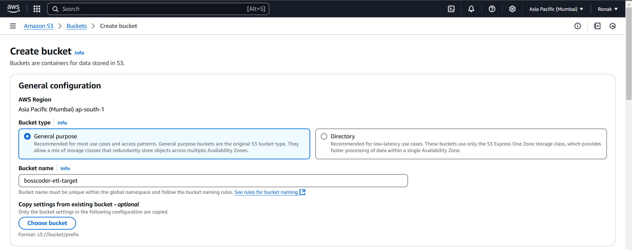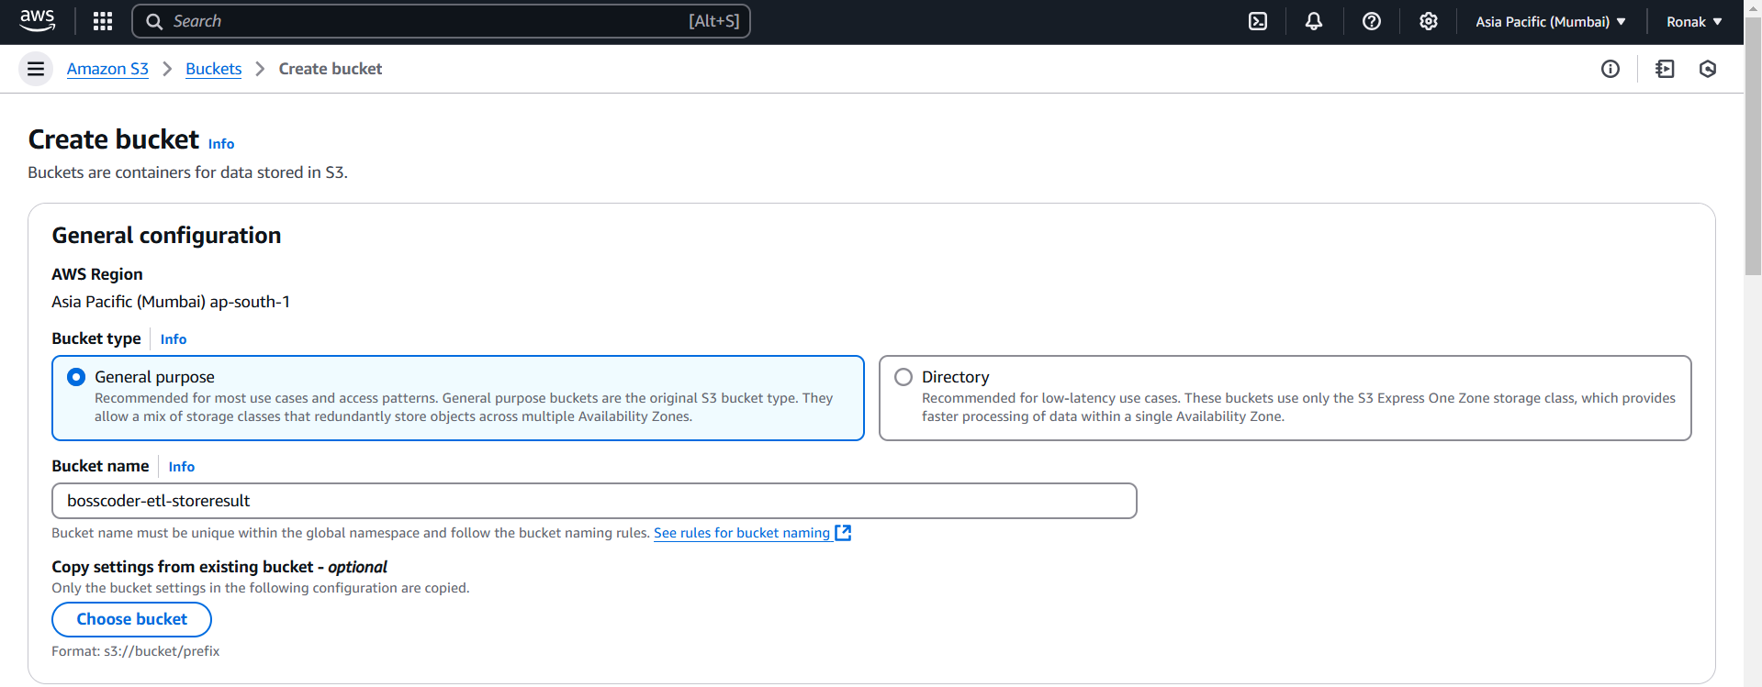
Step 2: In the "Choose a use case" section, select "Glue" to create a service role for AWS Glue. Next, attach the necessary permission policies by searching for and attaching AmazonS3FullAccess, which grants full access to Amazon S3, and AWSGlueServiceRole, which provides the required permissions for AWS Glue to interact with other AWS services.
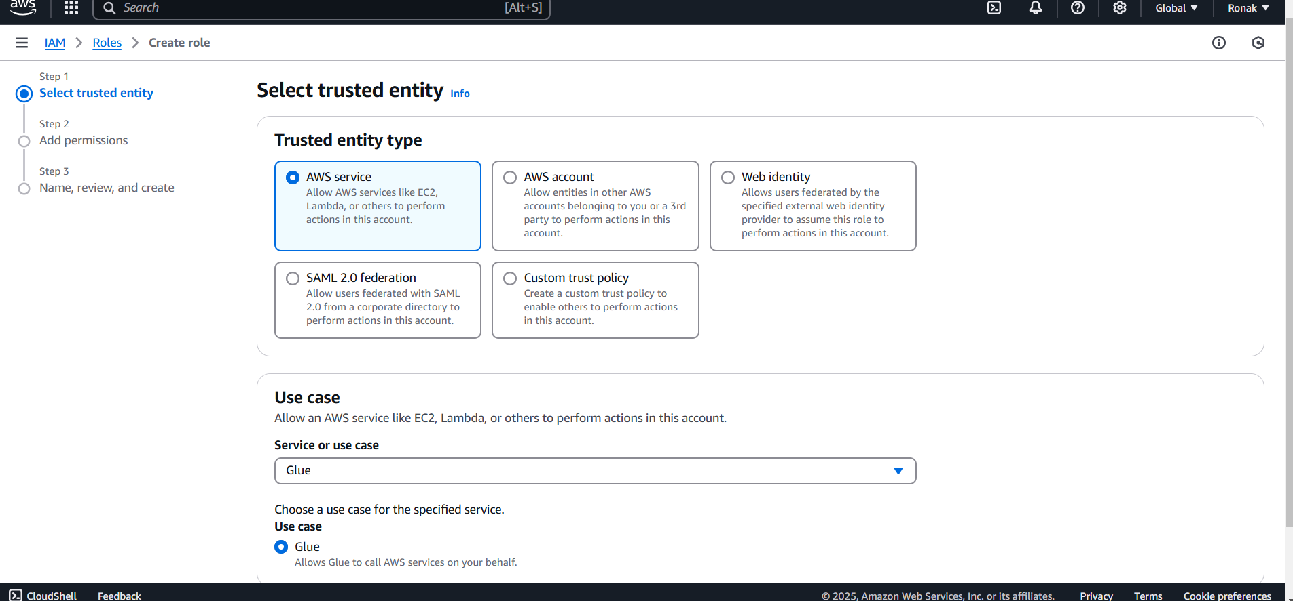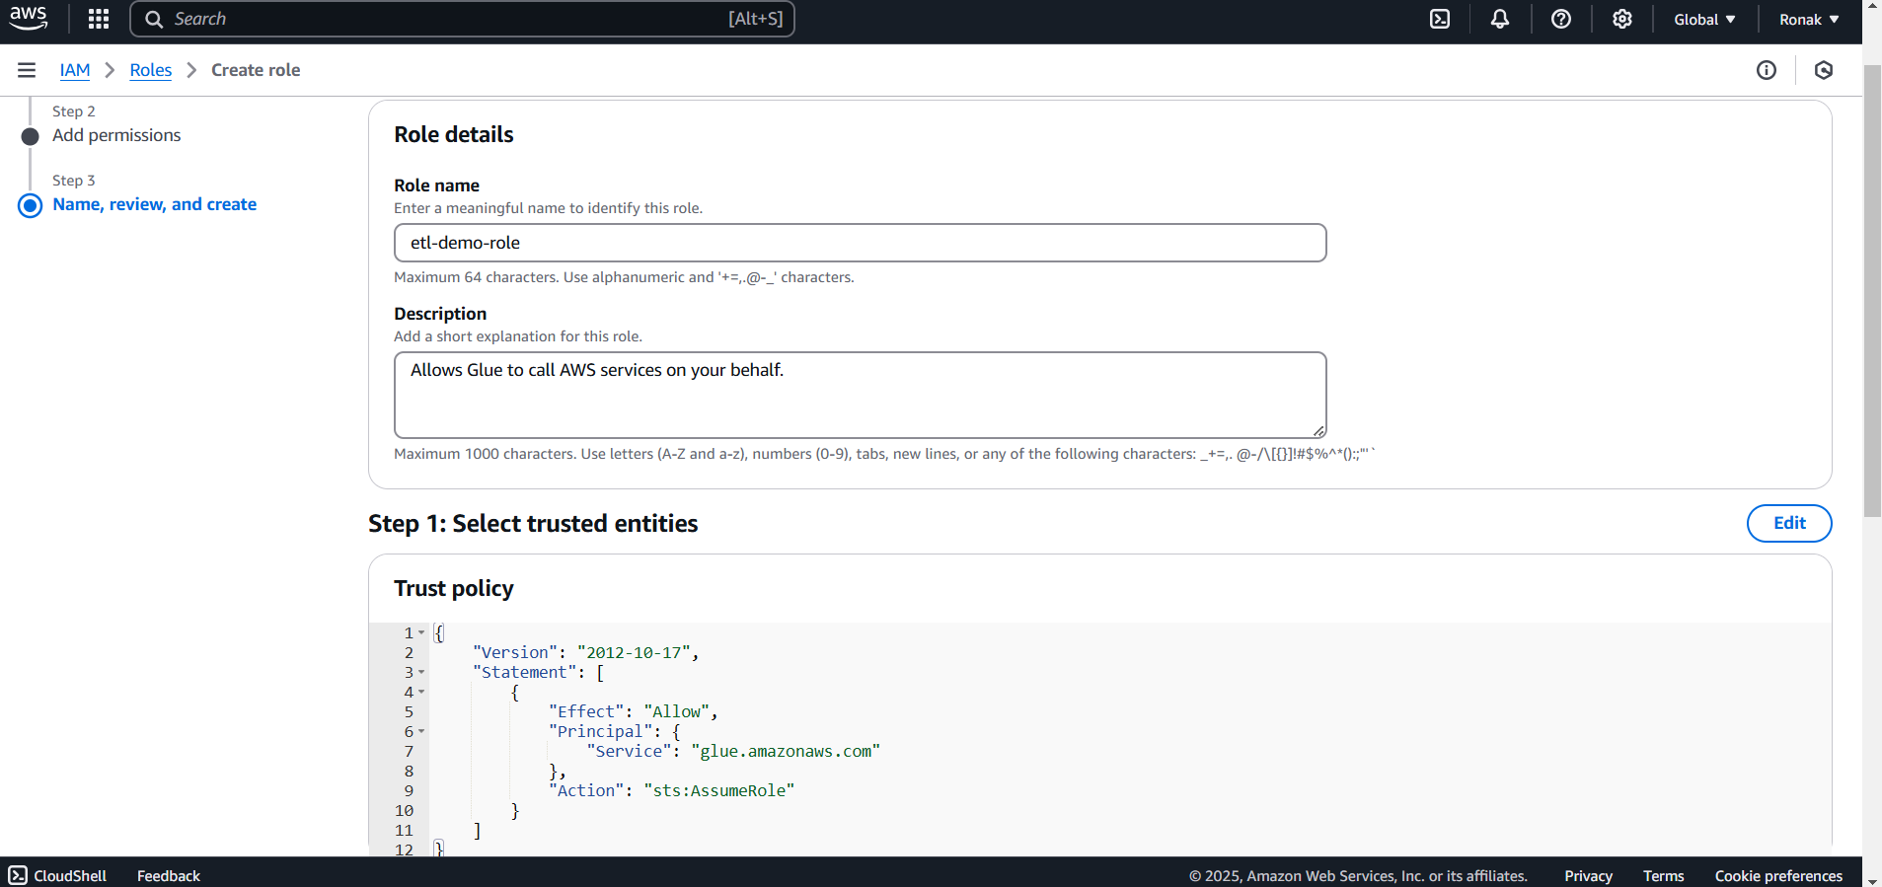
Step 3: Upload the CSV files that you want to process into the source S3 bucket. To ensure smooth query execution in Amazon Athena, first, create a folder inside the bucket and then upload the CSV files into that folder. This helps prevent issues where queries return zero records due to Athena’s requirement for properly structured data within the S3 bucket.
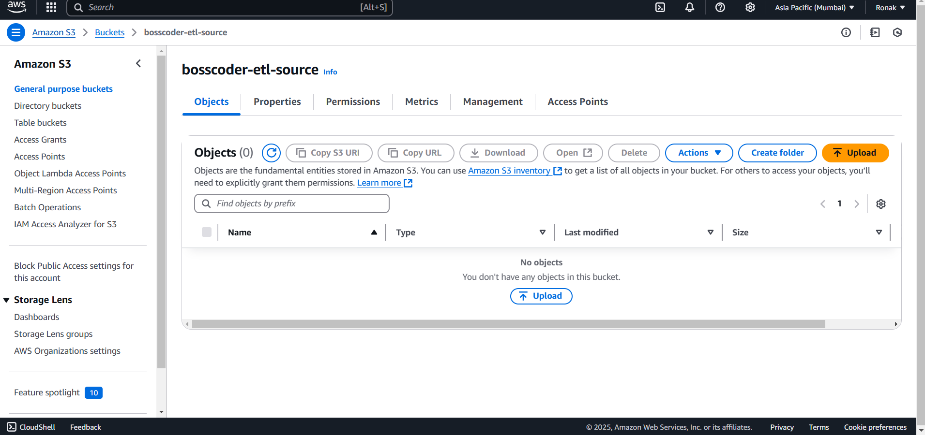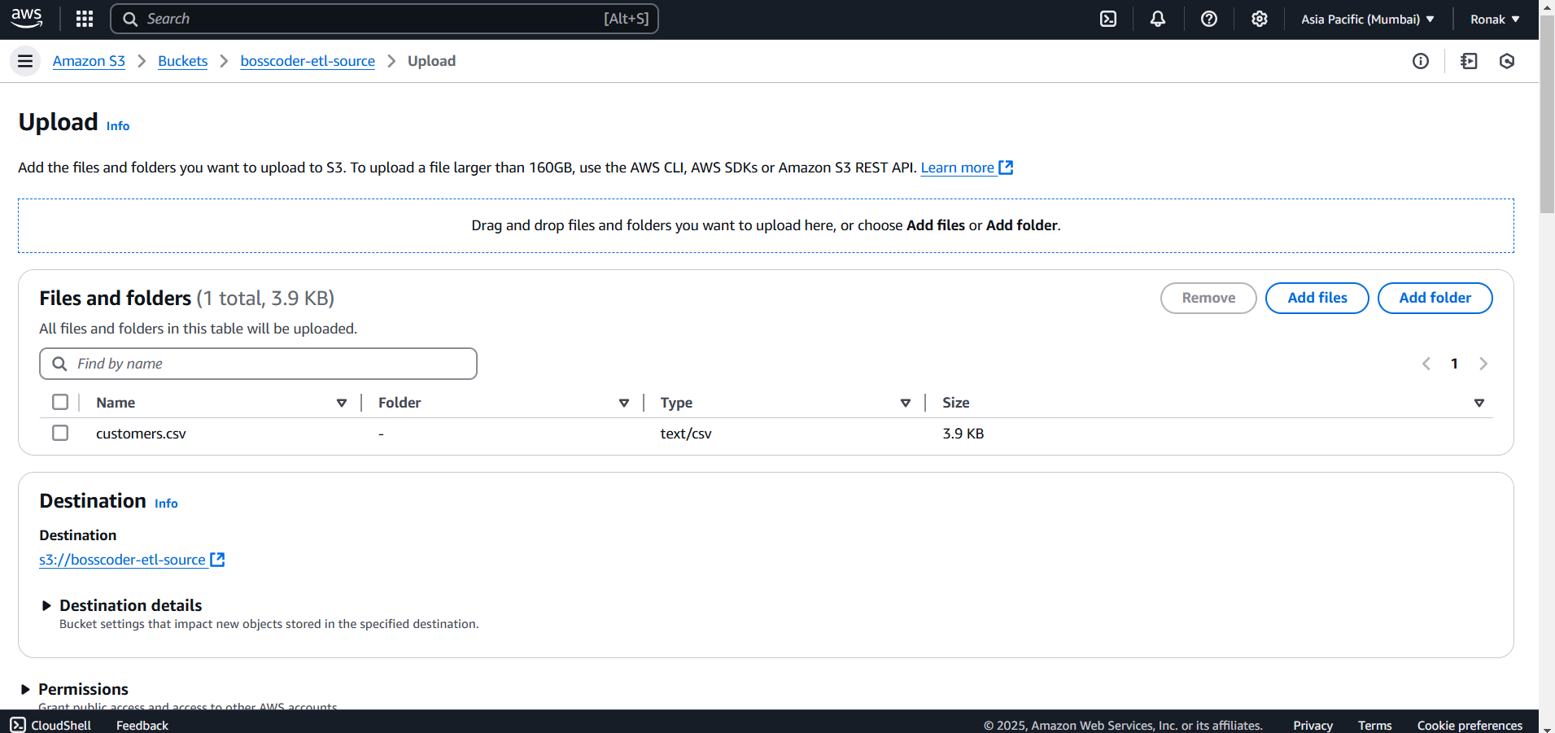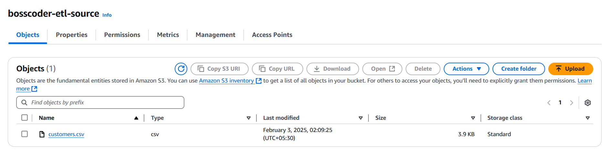
Step 4:
1. Go to AWS Glue Console
- Navigate to the AWS Glue service in the AWS Management Console.
- Click on Crawlers in the left-hand menu.
2. Create a Crawler
- Click "Add Crawler" to start the crawler creation process.
- Provide a name for the crawler.
- Choose "S3" as the data store.
- Specify the S3 path to the source bucket where the CSV files are stored.
- Follow the wizard steps and complete the configuration.
3. Choose a Database & Add Database
- Select an existing database or create a new database in AWS Glue.
- Initially, the database will not contain any tables since the schema has not been discovered yet.
4. Run the Crawler
- After creating the crawler, run it to analyze the CSV files in the S3 bucket.
- The crawler will scan the data and infer the schema, creating metadata entries in the AWS Glue Data Catalog.
- While running, the status will show as "Running".
5. Check the Crawler Status
- Once the crawler completes its execution, the status changes to "Completed" and then "Stopping".
- After completion, go inside the selected database, and now you will see the tables created based on the discovered schema.
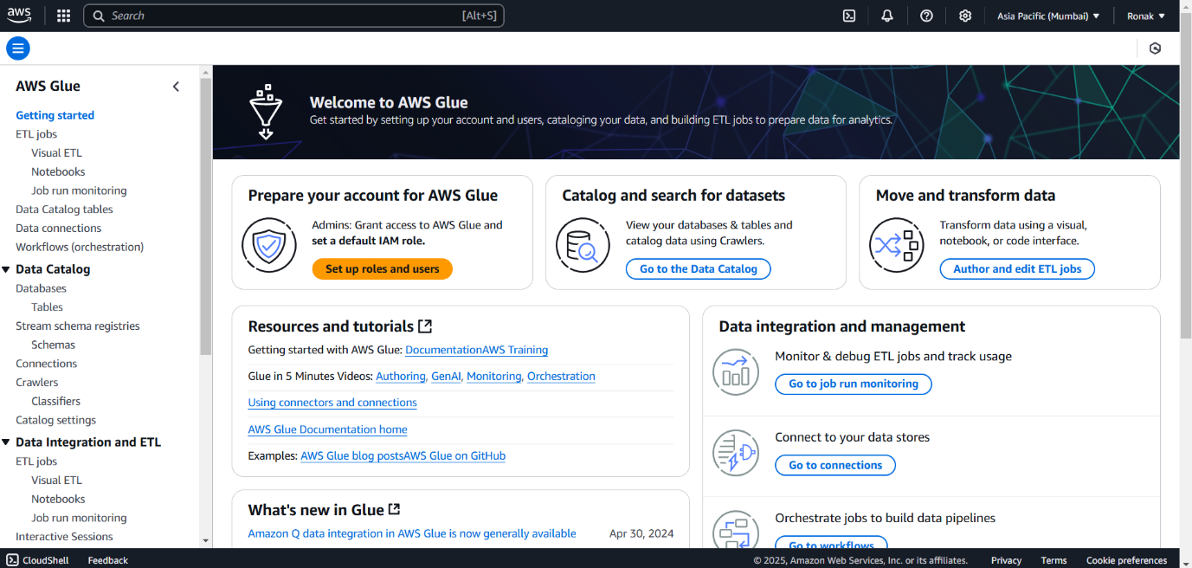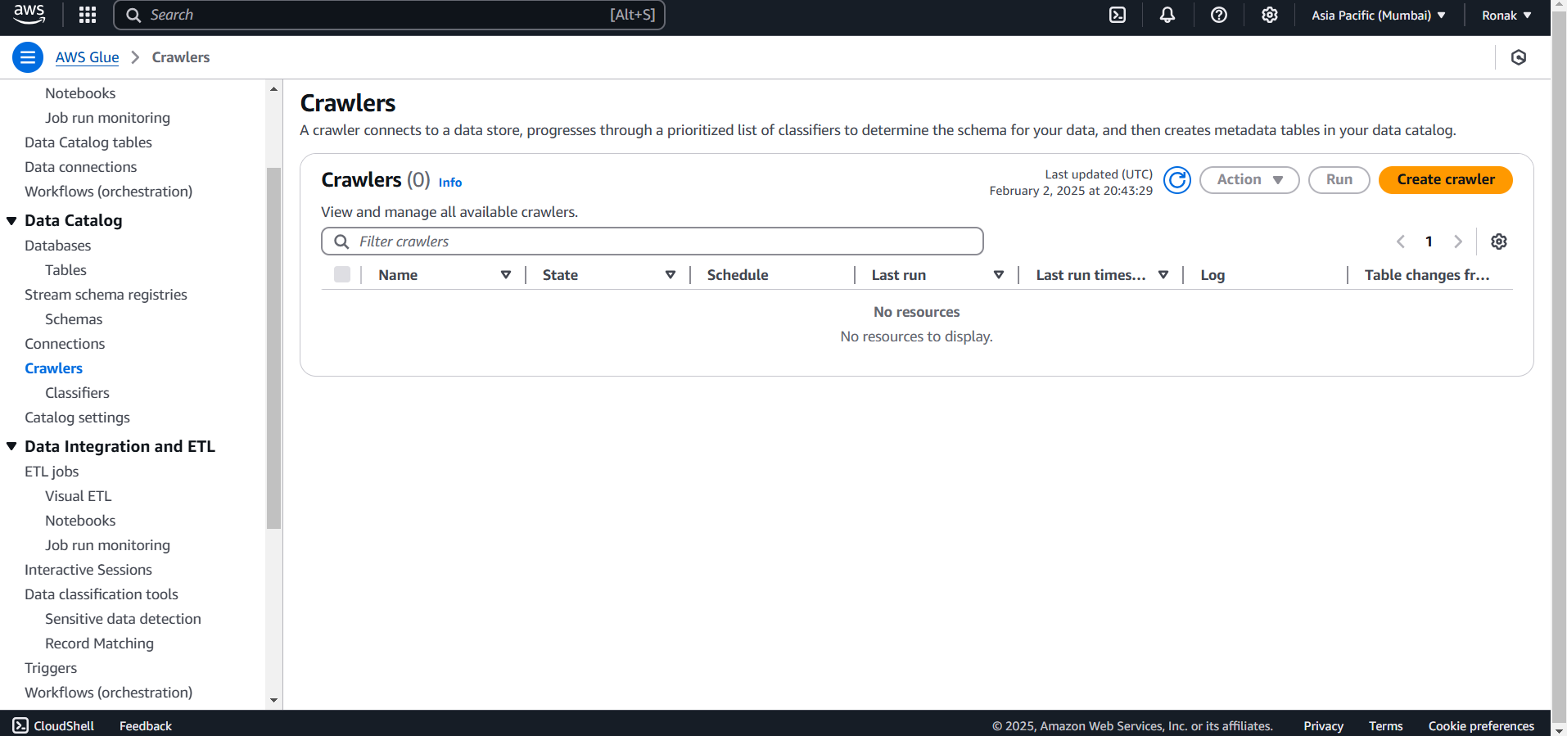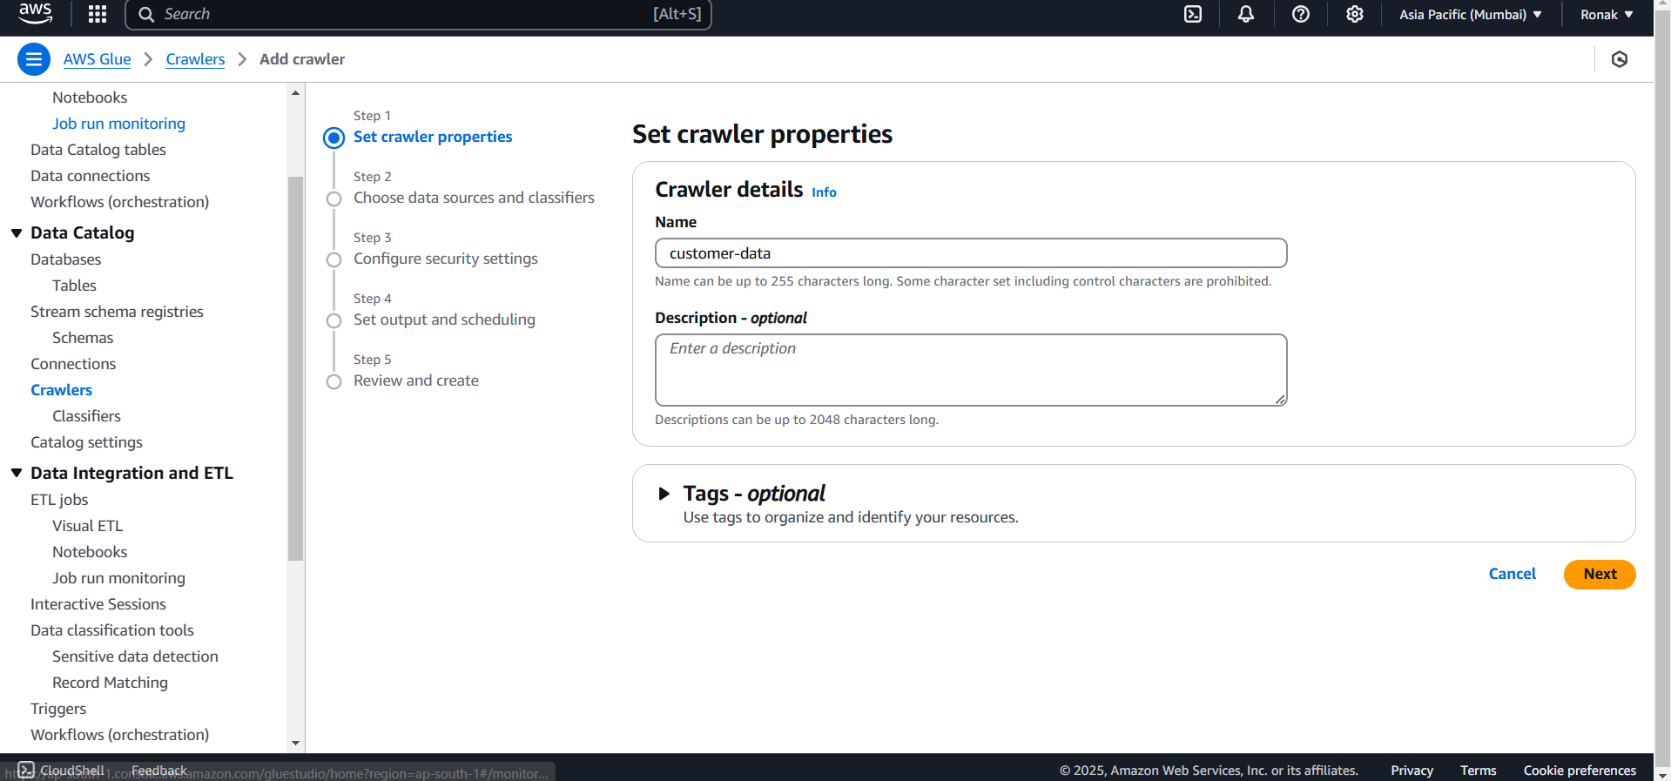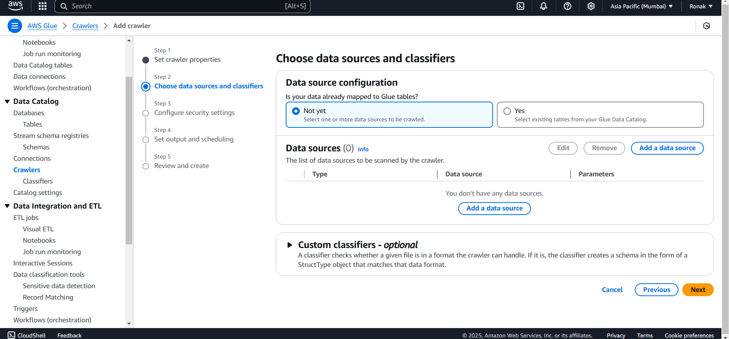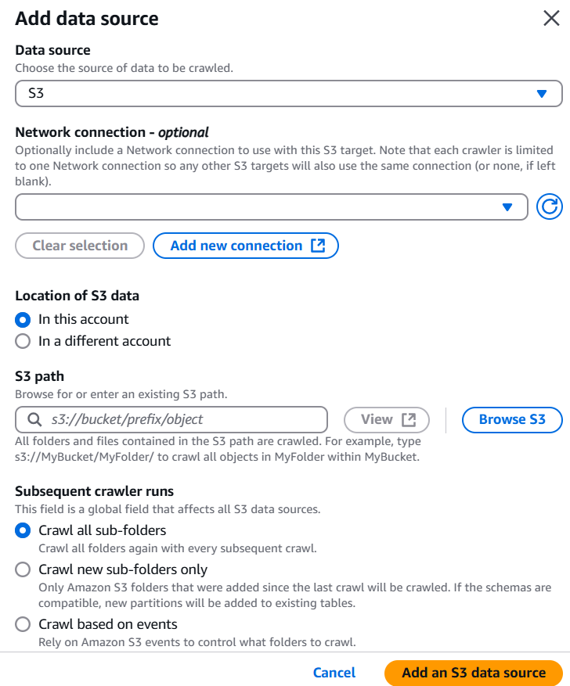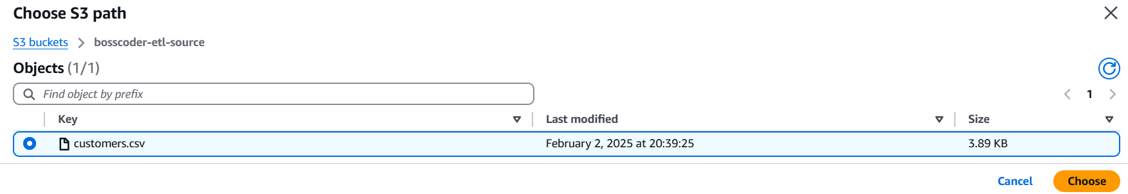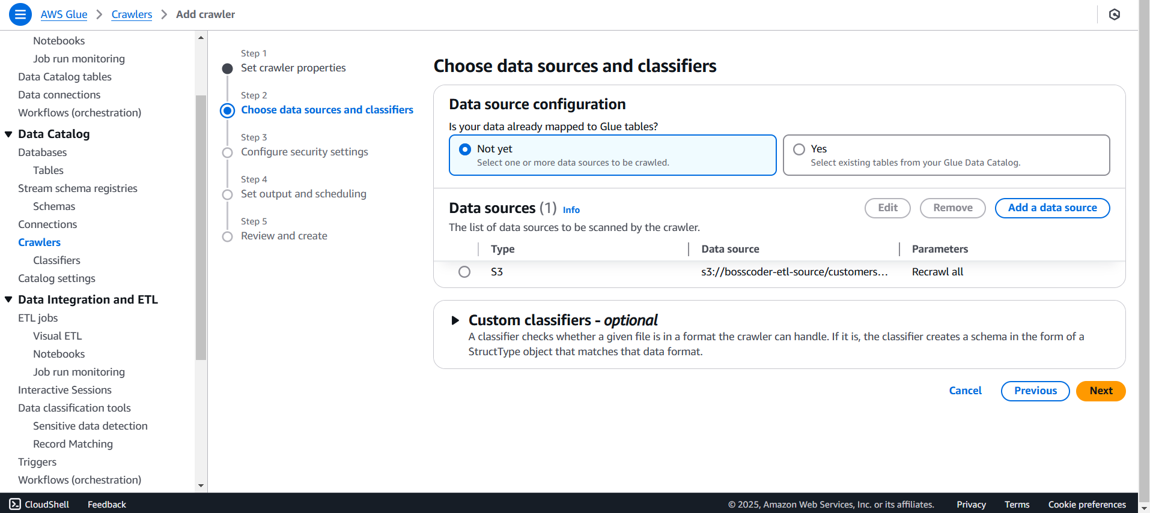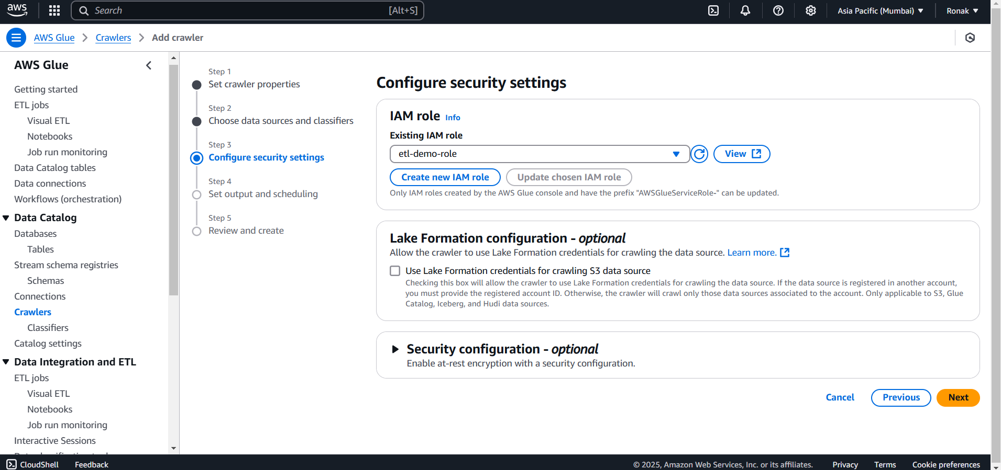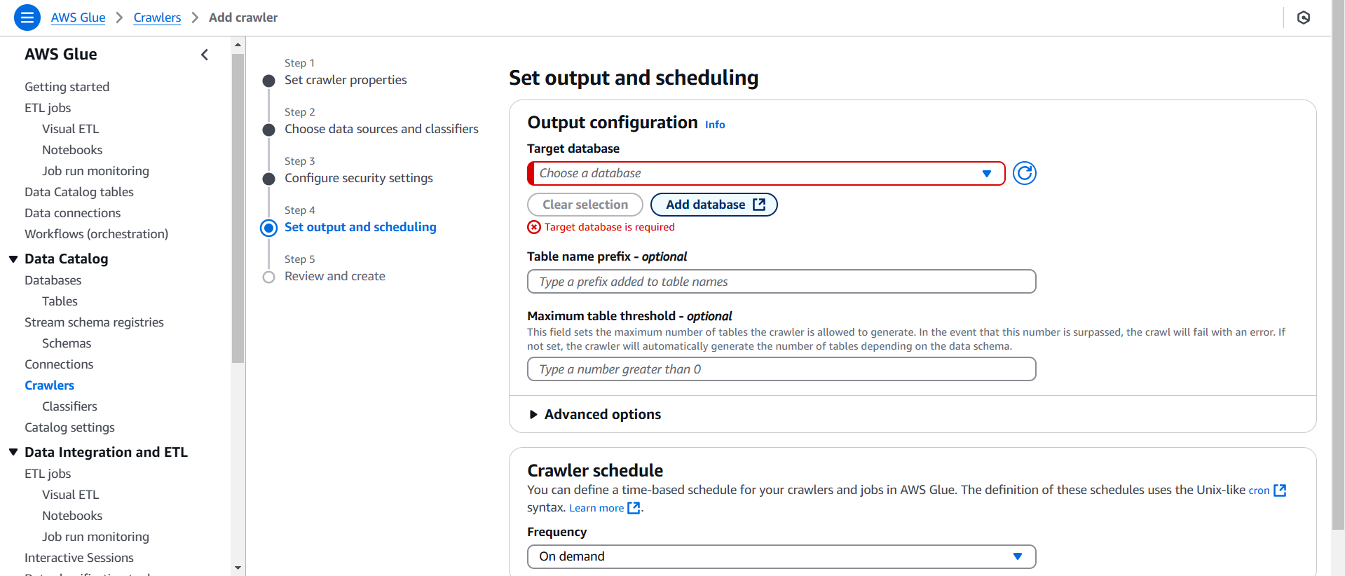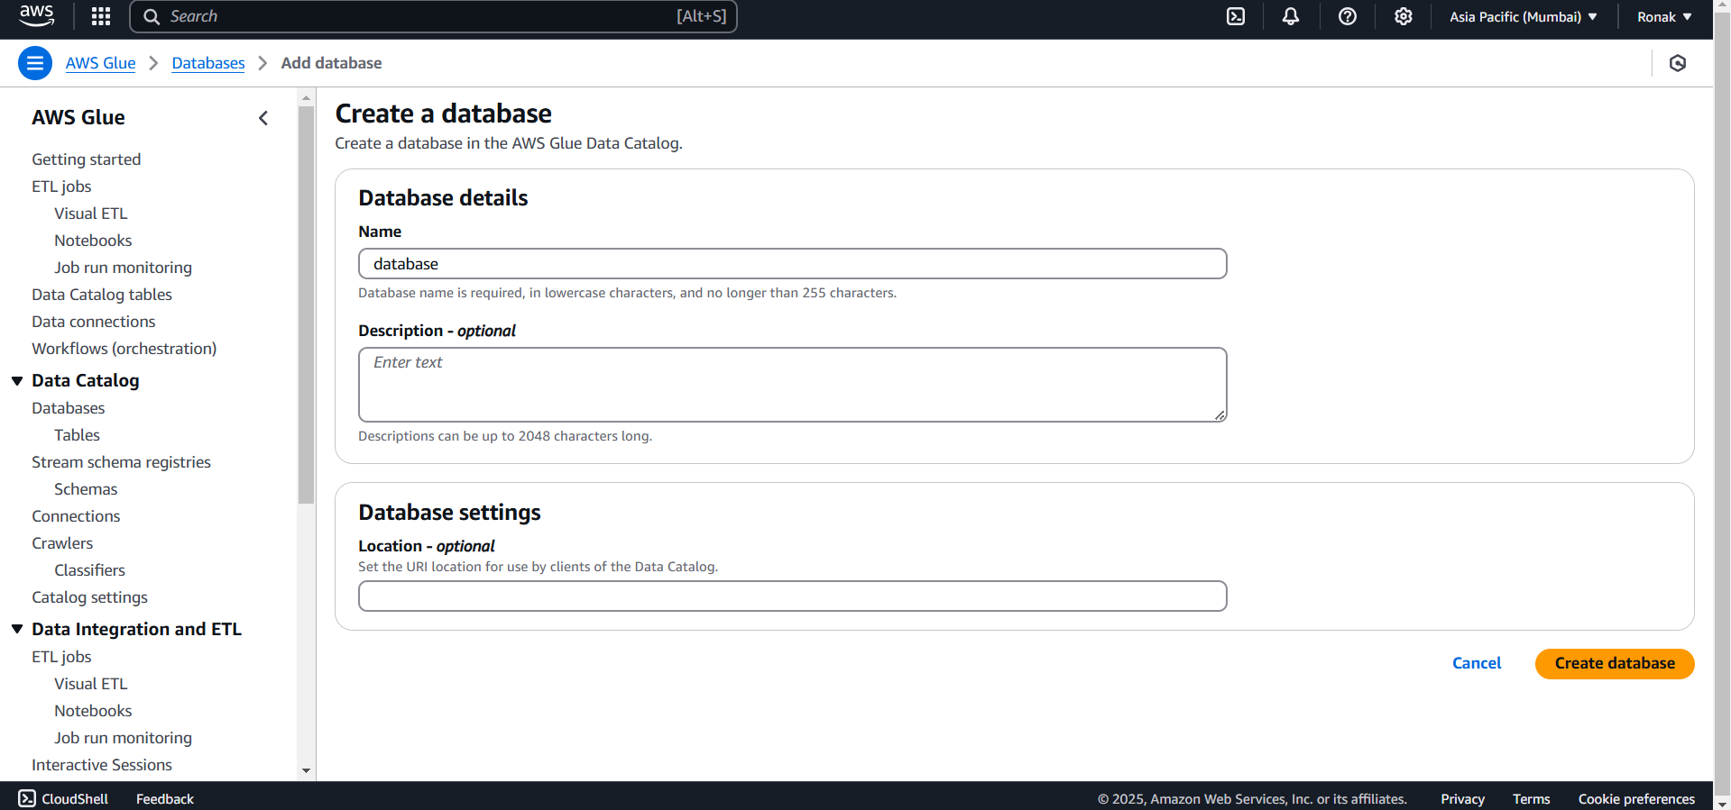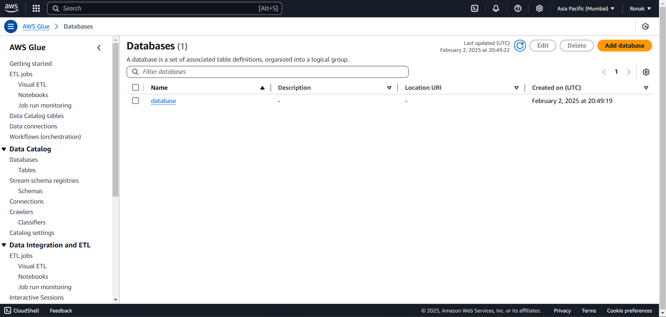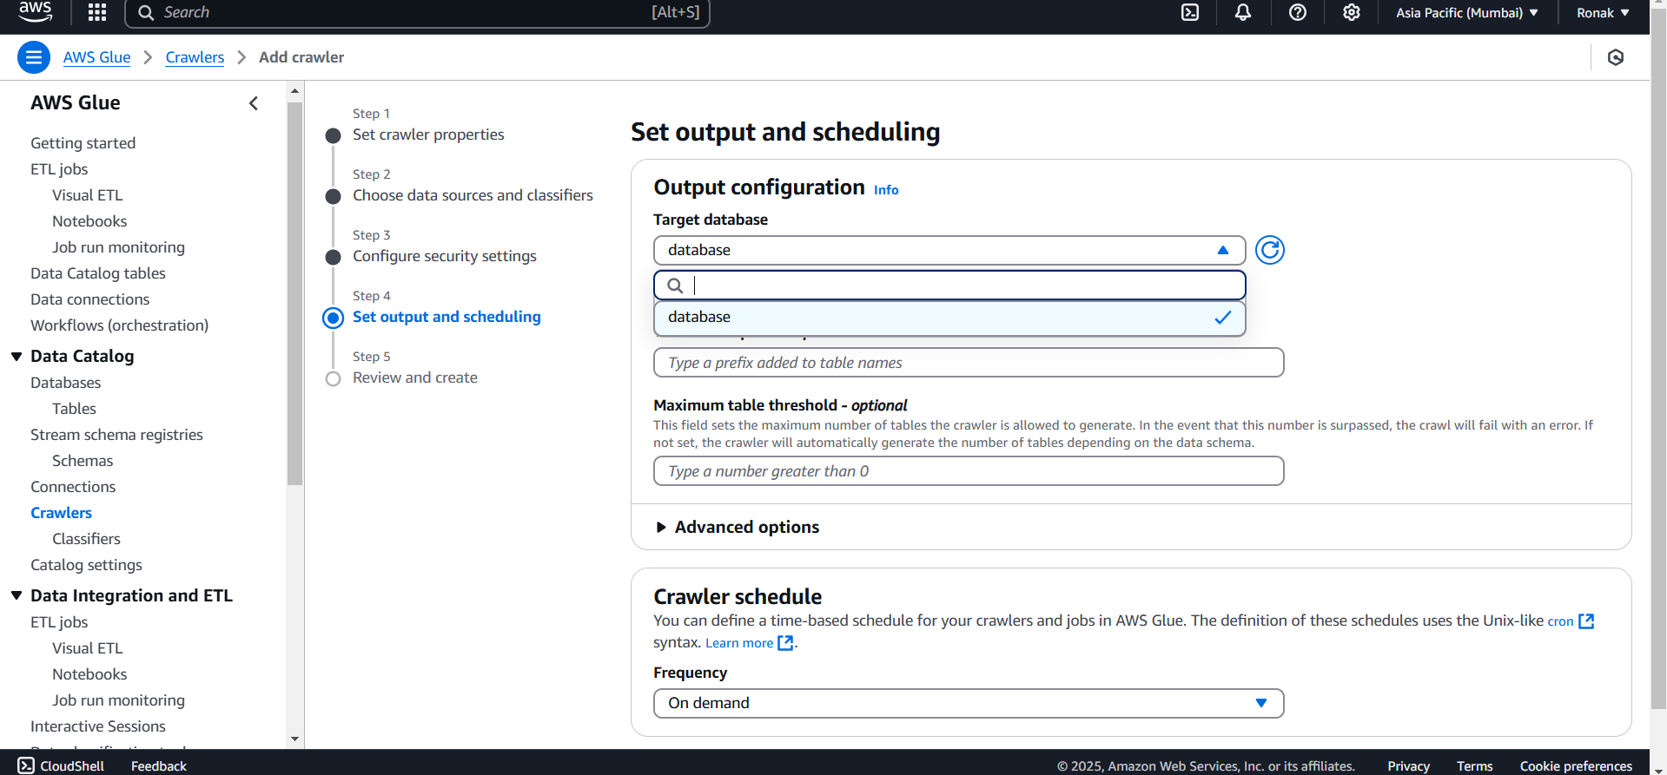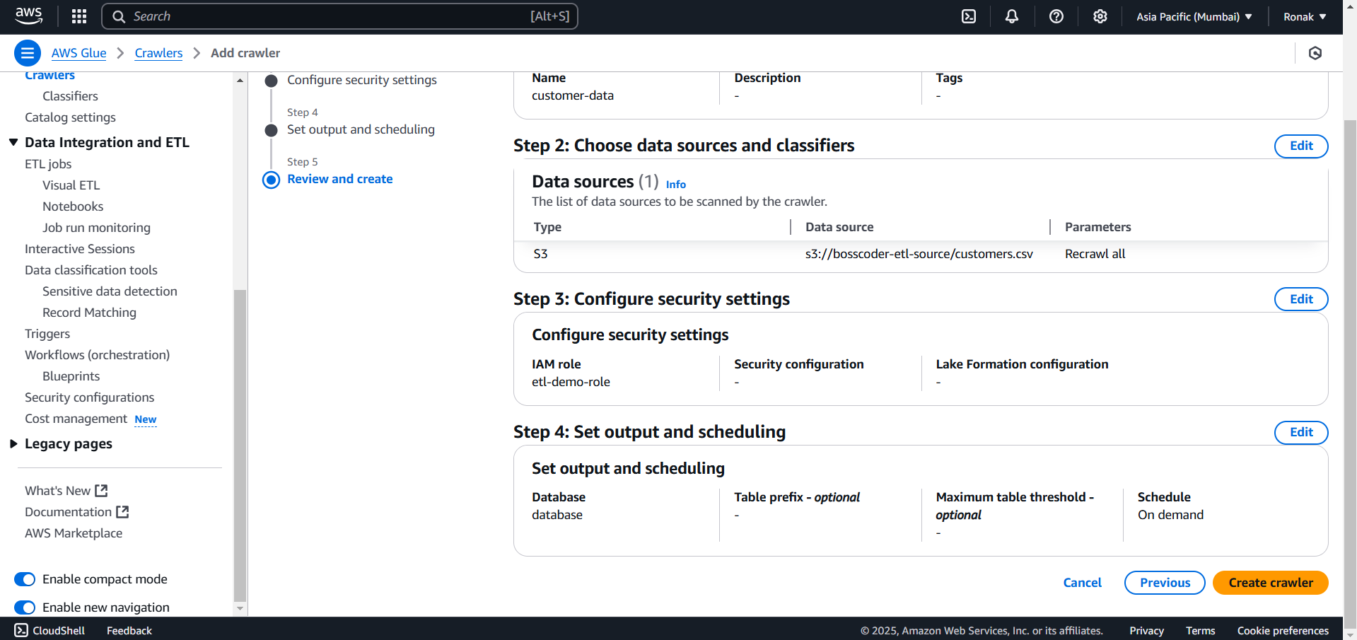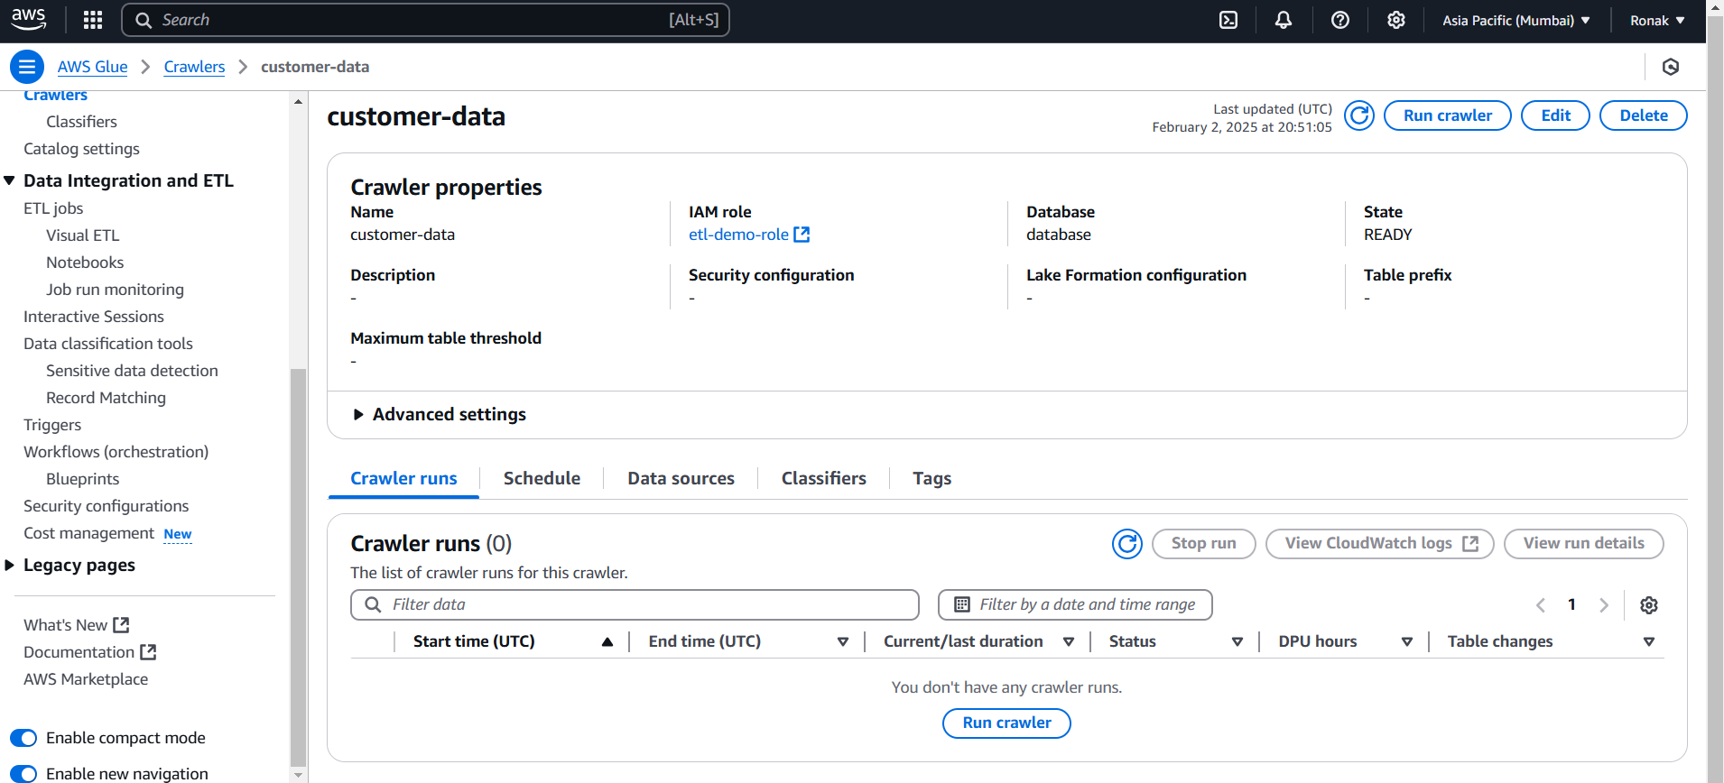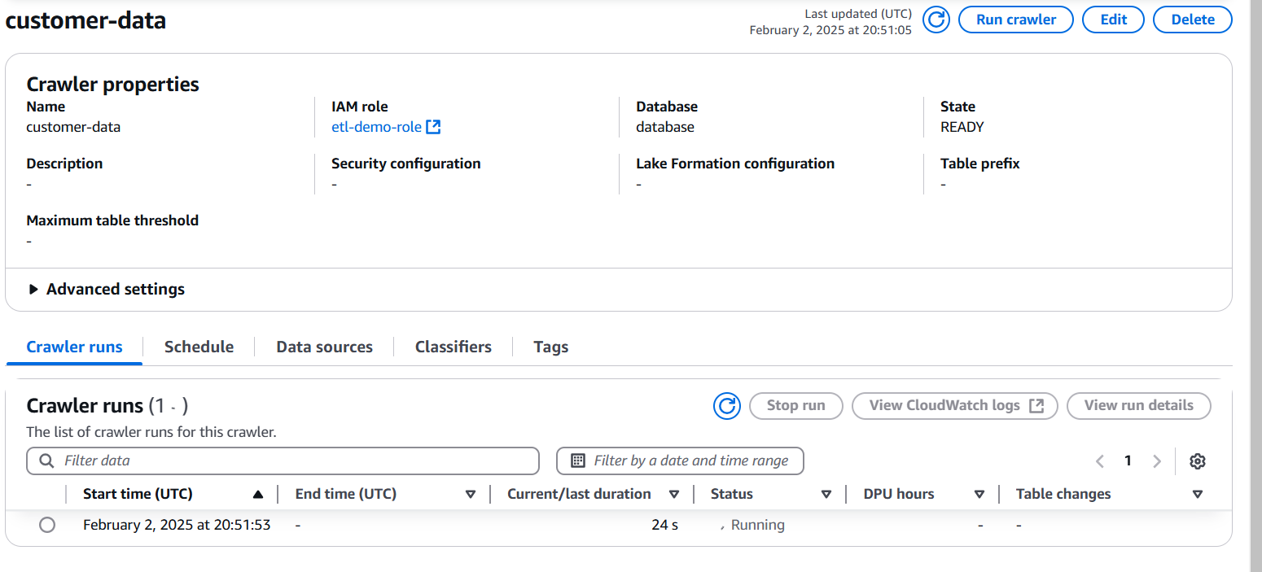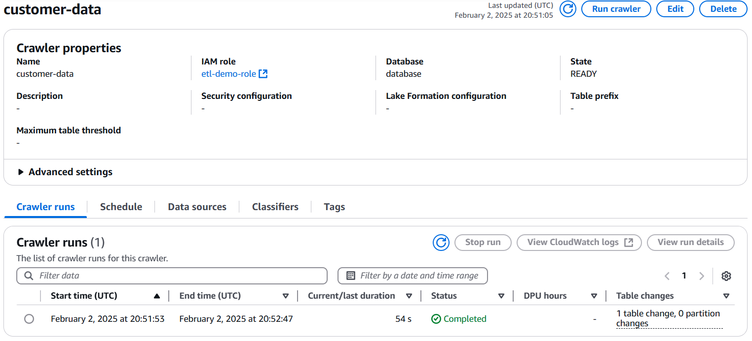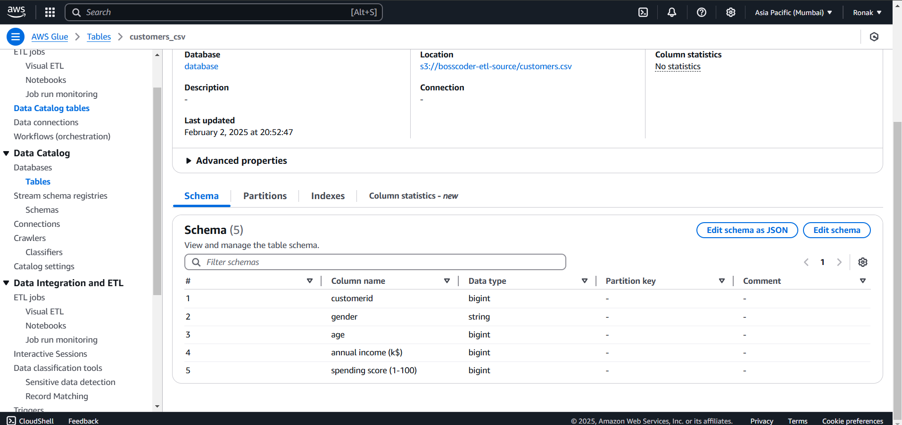
Step 5:
1. Go to AWS Glue Console
- Open the AWS Glue service in the AWS Management Console.
- Click on “Jobs” in the left sidebar.
2. Create an AWS Glue ETL Job
- Click "Add job" and follow the wizard to configure the ETL job.
- Provide a name for the job.
- Choose the source and target connections for data processing.
- Define the transformation logic using an AWS Glue ETL script.
- Complete the wizard to create the job.
3. Configure Source, Target, and Transformation Buckets
- Select Source Bucket → Choose Amazon S3 and use the AWS Glue Data Catalog table for structured data input.
- Select Target Bucket → Define the destination S3 bucket where transformed data will be stored.
- Select Transform Bucket → Choose Amazon S3, specifying transformation logic with a customer ID field.
4. Configure Job Details Before Running
- Go to the Job details section.
- Set the name of the job.
- Select the IAM role that grants necessary permissions for Glue to access S3 and other services.
- Click Save to apply the settings.
5. Run the AWS Glue ETL Job
- Click "Run" to execute the ETL process.
- Navigate to the Runs section to monitor the job execution.
- Once the job succeeds, the transformed data will be stored in the target S3 bucket.
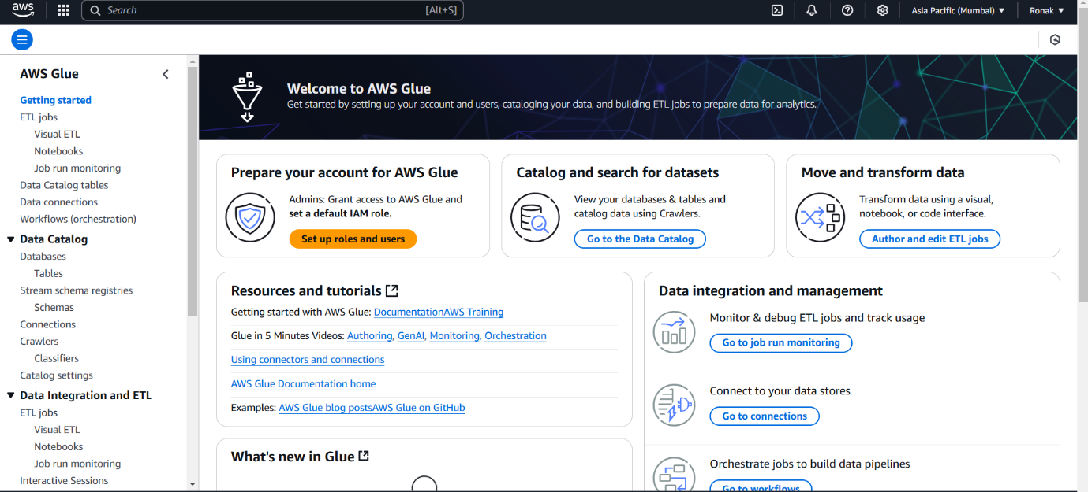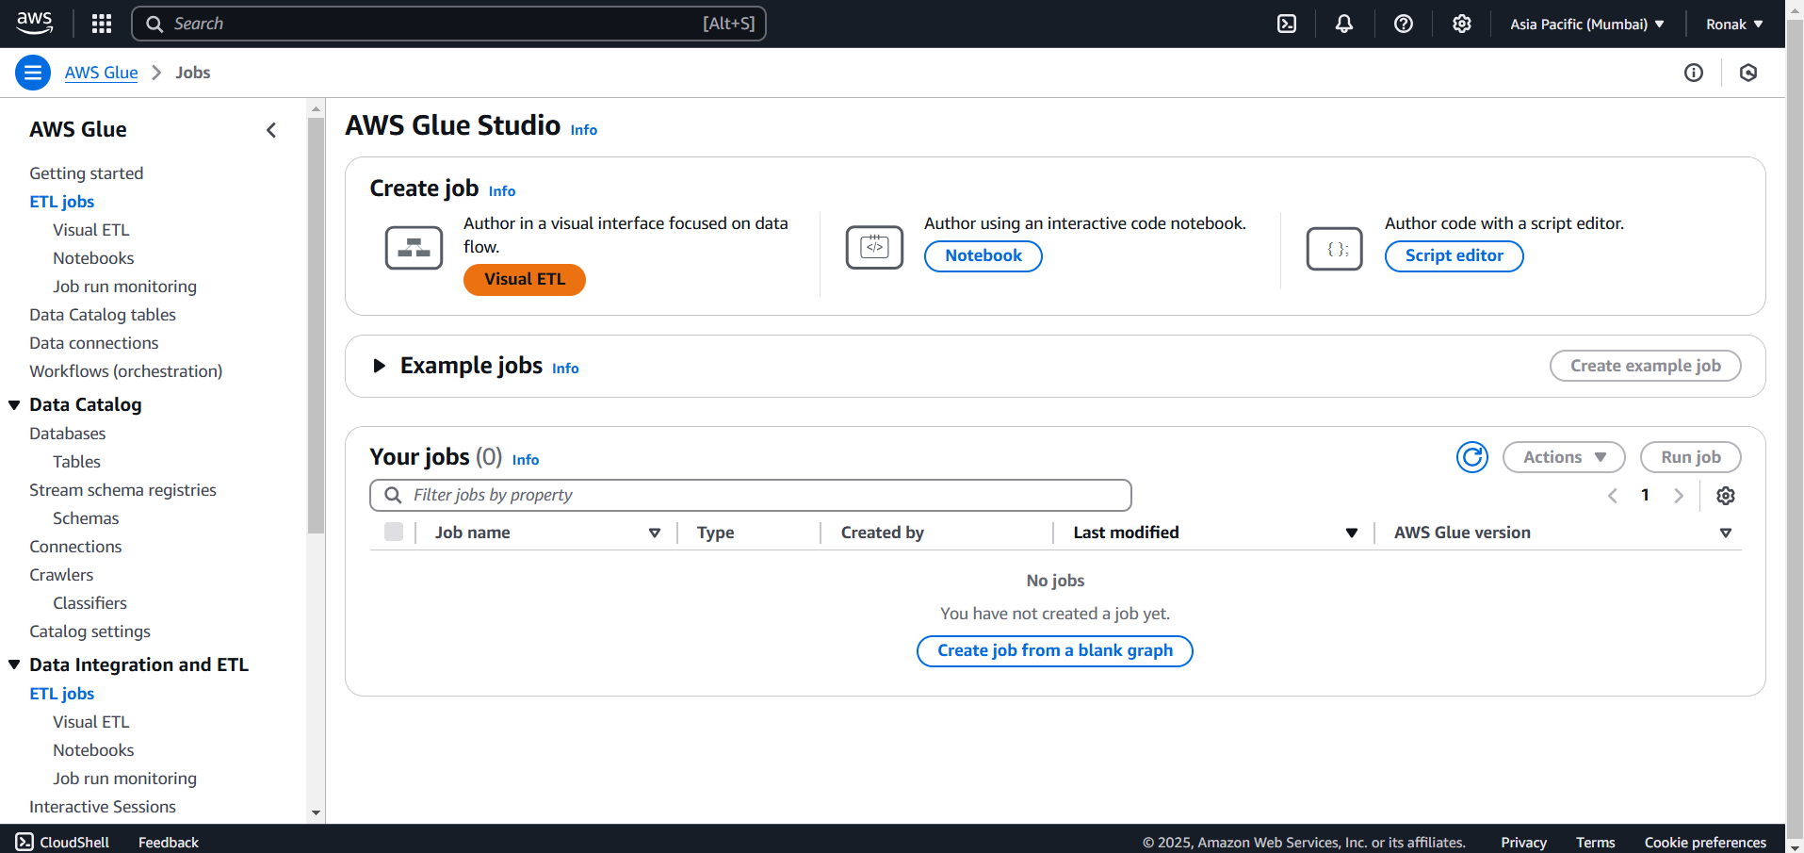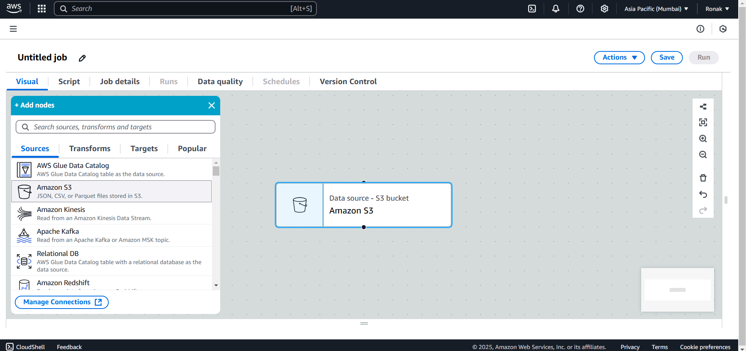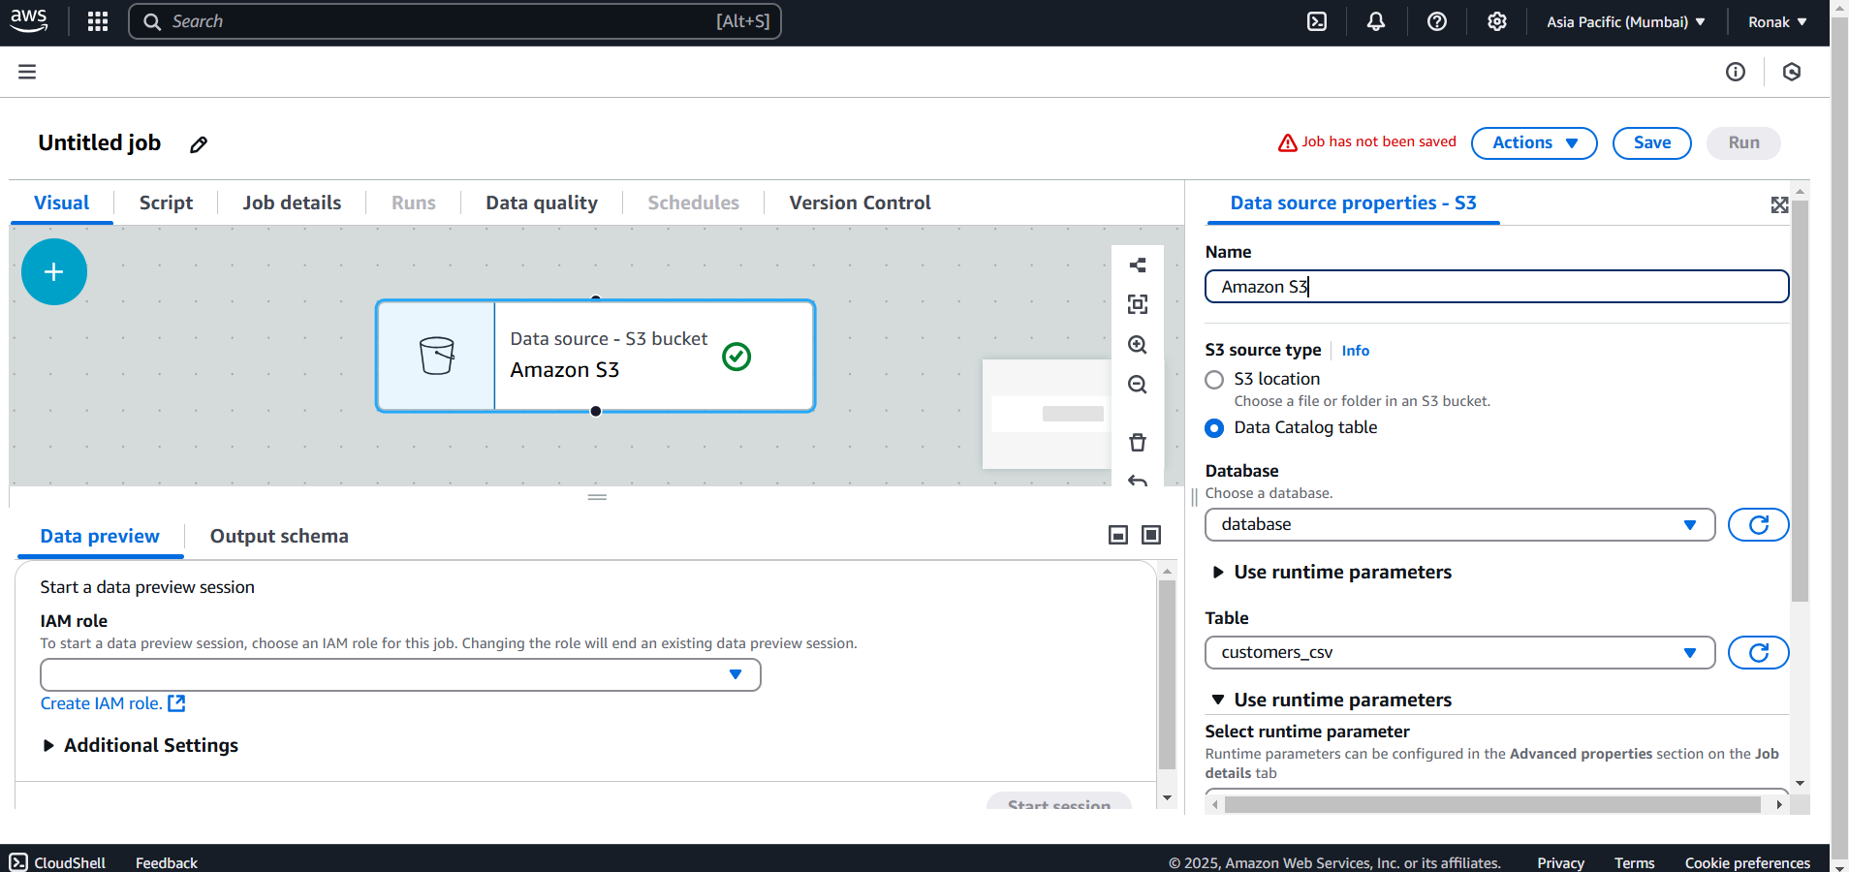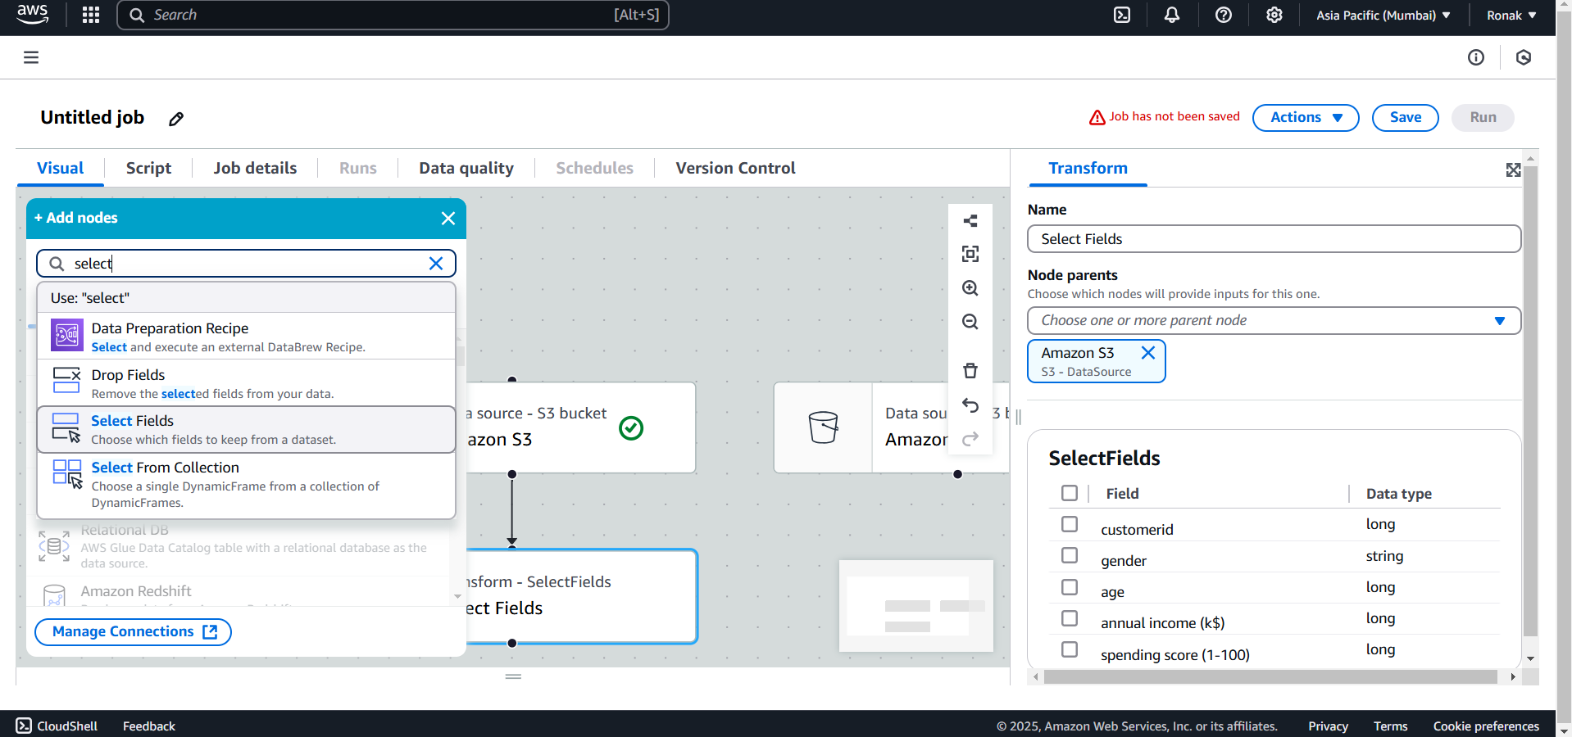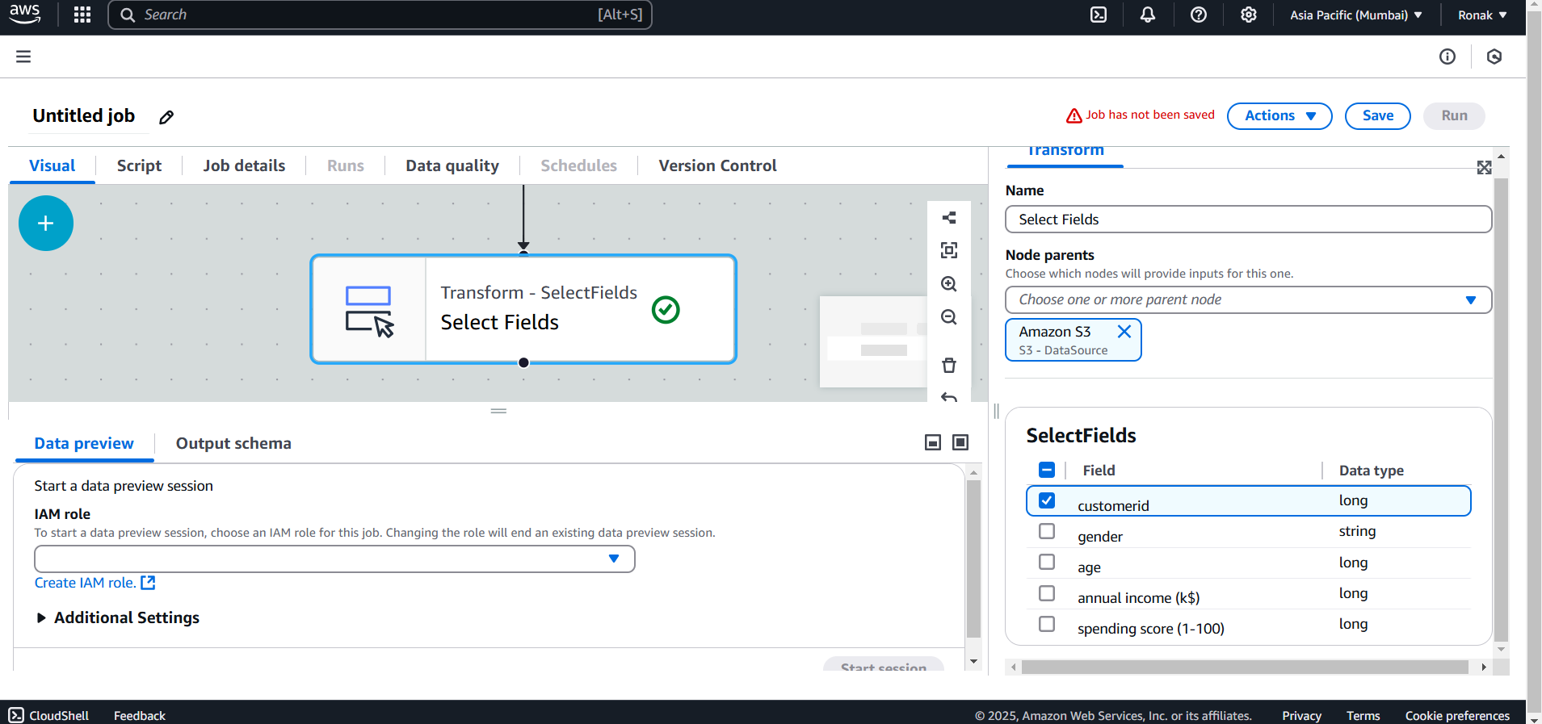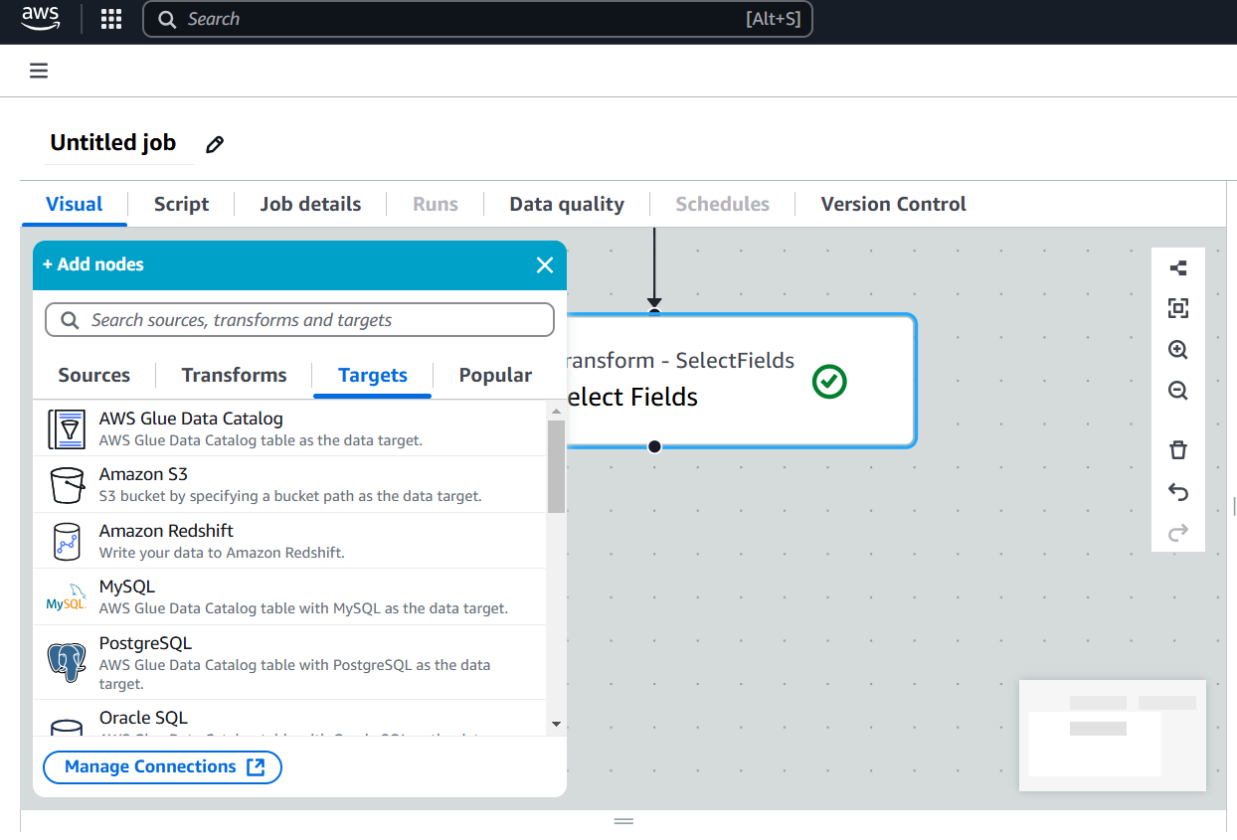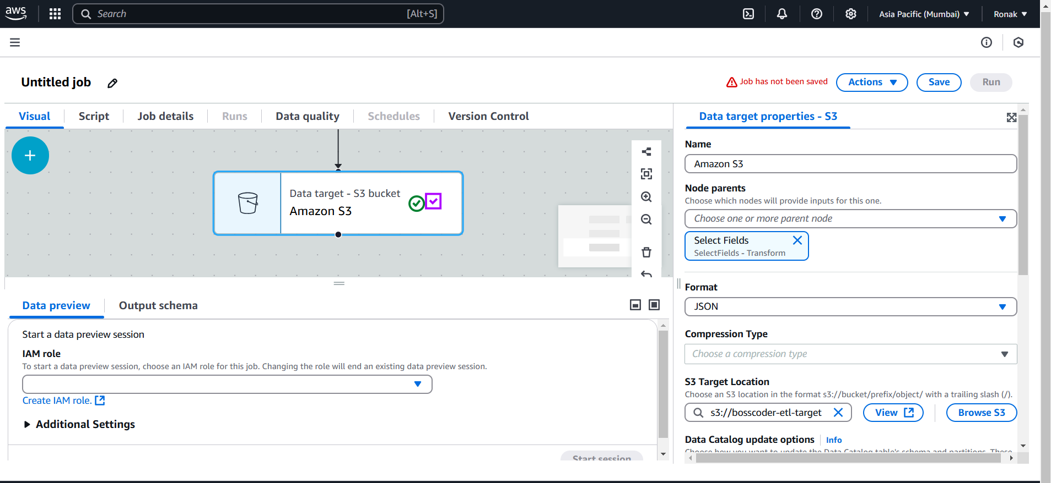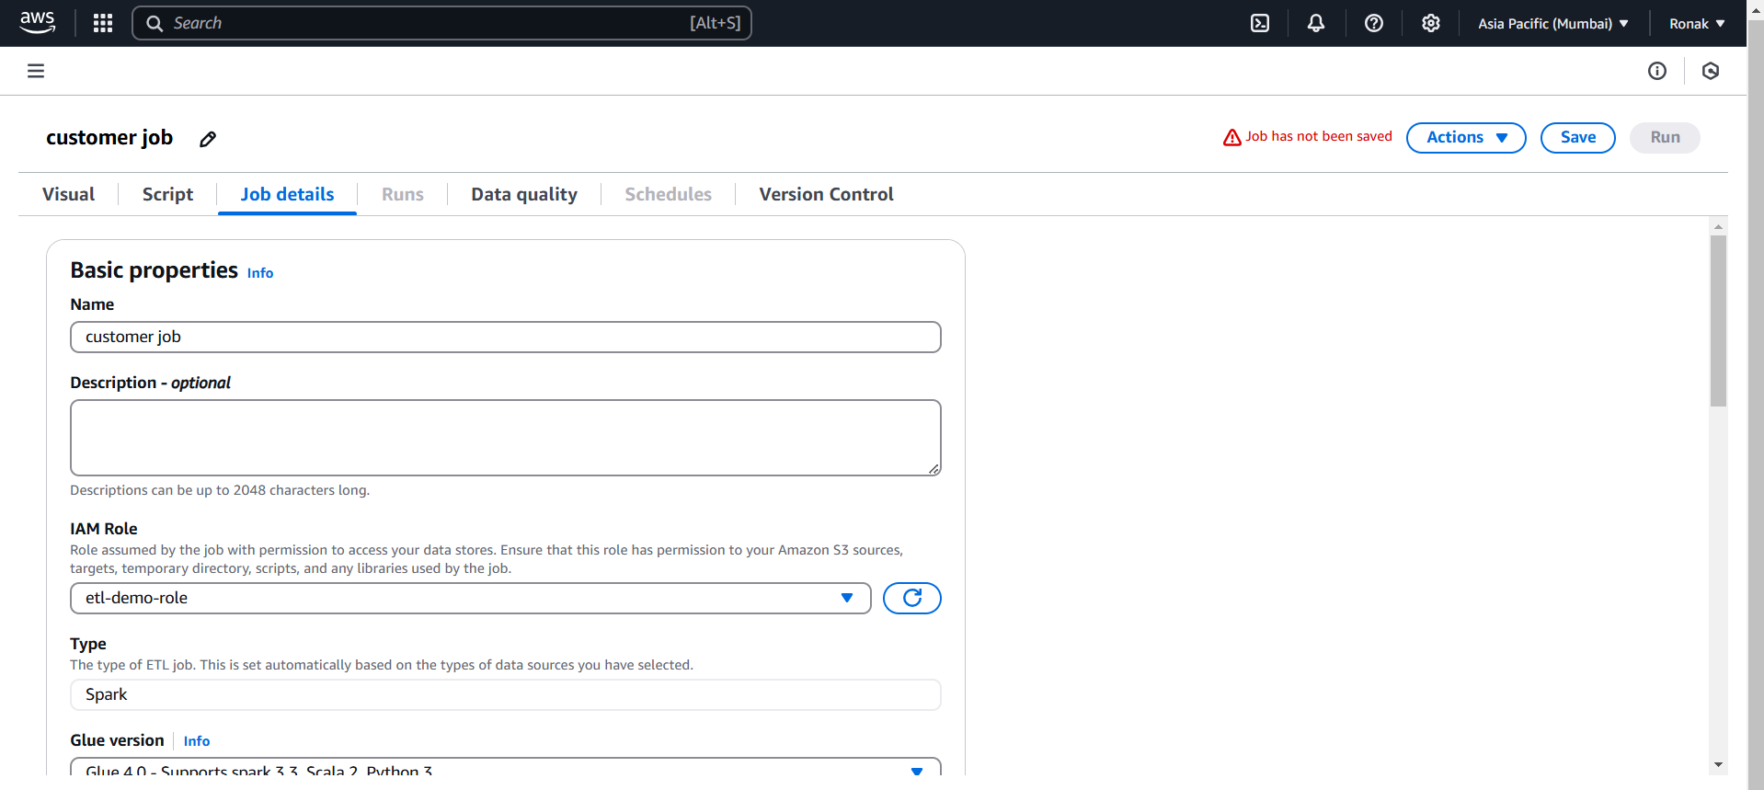
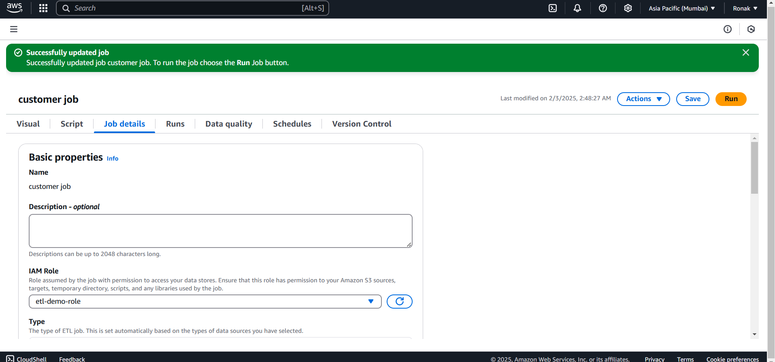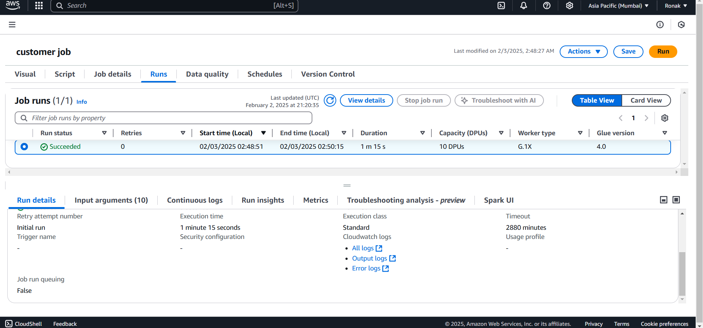
Step 6:
- After the AWS Glue ETL job completes successfully, verify that the transformed data has been loaded into the target S3 bucket.
- Navigate to the Amazon S3 Console and go to the target bucket specified in the ETL job.
- Check if the transformed file(s) have been automatically added to the bucket.
- Open the files to ensure the data is correctly processed and stored according to the transformation logic applied in AWS Glue.
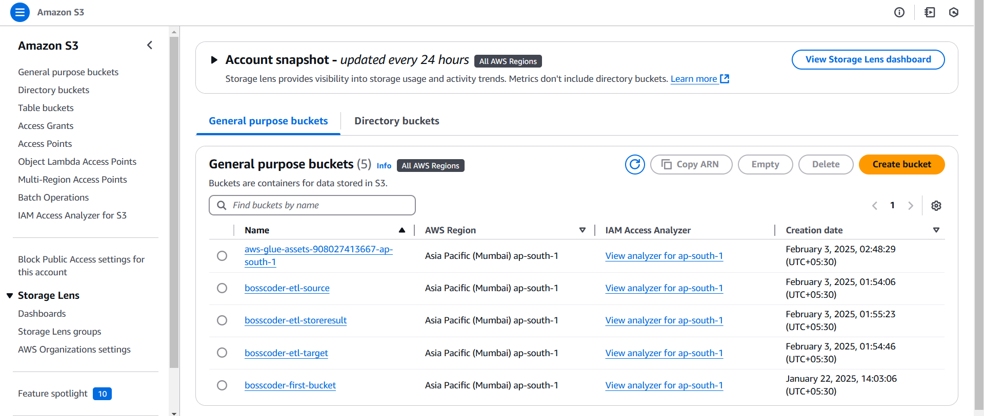
Step 7: Set Up Amazon Athena and Run Queries
- Open Amazon Athena from the AWS Management Console.
- Click "Action" → "View Data" to explore the tables created by AWS Glue.
- Initially, queries might not run because Athena requires an output location.
- Go to Settings → Click "Manage" → Browse S3 Bucket and select the Athena results bucket → Click Save.
- Use the Athena Query Editor to run SQL queries on the cataloged tables and analyze the transformed data.
- Execute queries as per your requirement, and Athena will retrieve the relevant data from the S3 bucket.
